Tasks for Docker-01.
- Setup a virtual machine using Ubuntu image.
Stpes:
- Install VirtualBox
- Download Ubuntu ISO From Ubuntu official site
Download: Ubuntu 24.04.3 LTS ISO file
- Create New Virtual Machine
Steps:
Open VirtualBox → Click New
Fill details: Name → Ubuntu-VM
Type → Linux
Version → Ubuntu (64-bit)

- Attach Ubuntu ISO
Steps:
Select VM → Click Settings → Go to Storage → Under Controller → Empty
Click CD icon → Choose ISO file → Select downloaded Ubuntu ISO
- Start Virtual Machine & Install Ubuntu
Steps:
Click Start → Select → Install Ubuntu
Follow steps:
  - Language → English
  - Keyboard → Default
  - Installation → Normal
  - Disk → Erase disk (only VM disk, safe)
  - Create username + password
- Reboot & Login
- After installation completes → Restart
- Remove ISO when prompted
Login with your credentials
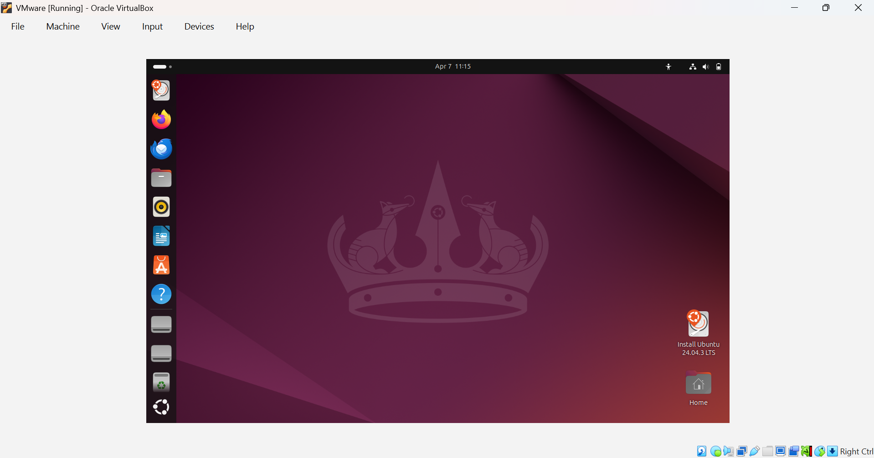

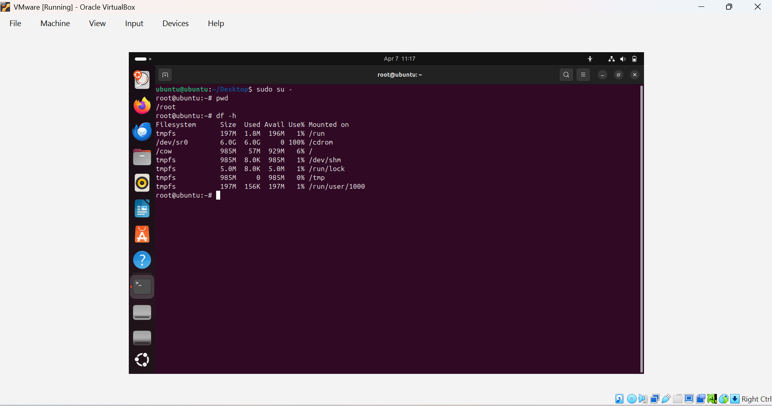

- Install docker on ec2.

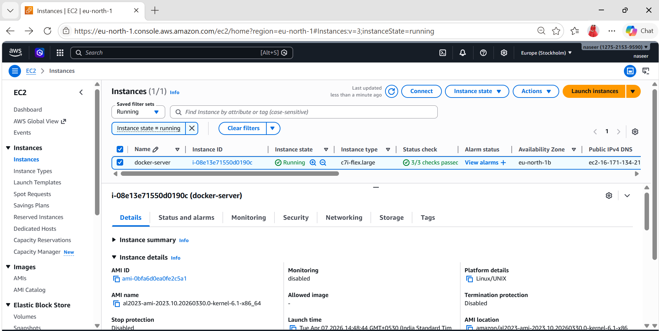

Sudo su –
Yum -y install docker
Systemctl status docker
Systemctl start docker
Systemctl status docker
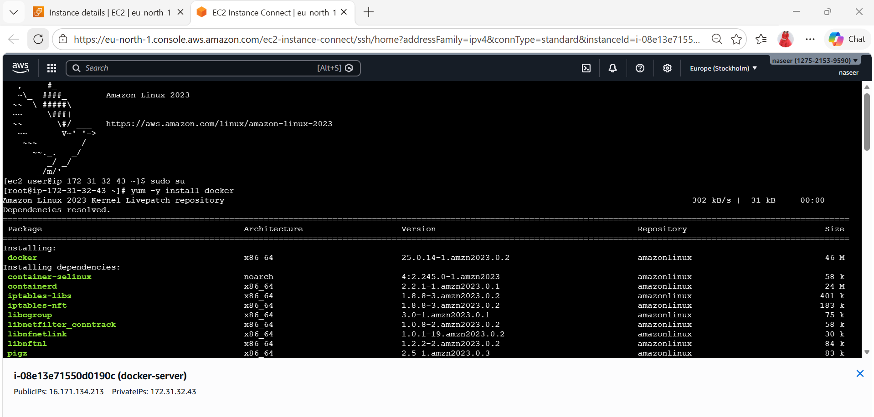
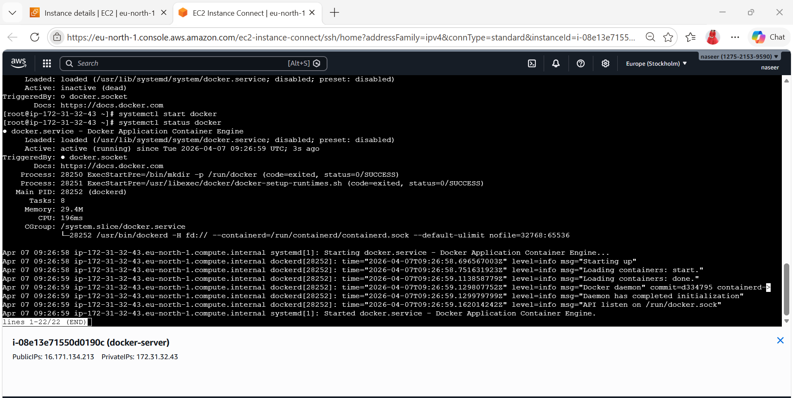

3) Pull 5 docker images.(nginx,apache tomcat,ubuntu,jenkins,sonarqube)
Docker image for Nginx
docker pull nginx
docker images
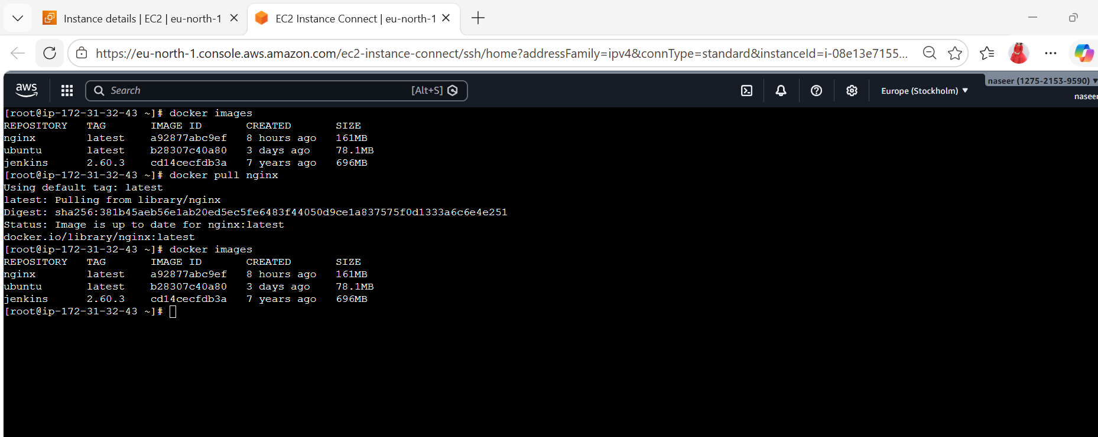

Docker image for Tomcat
docker pull tomcat
docker images

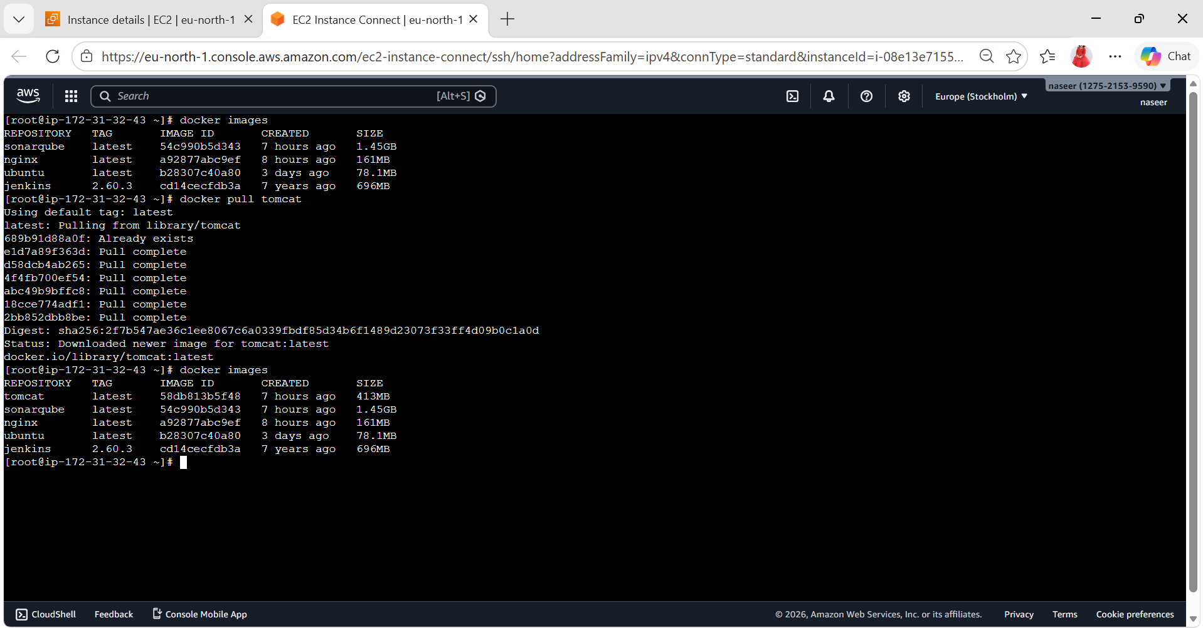
Docker image for Ubuntu
docker pull ubuntu
docker images
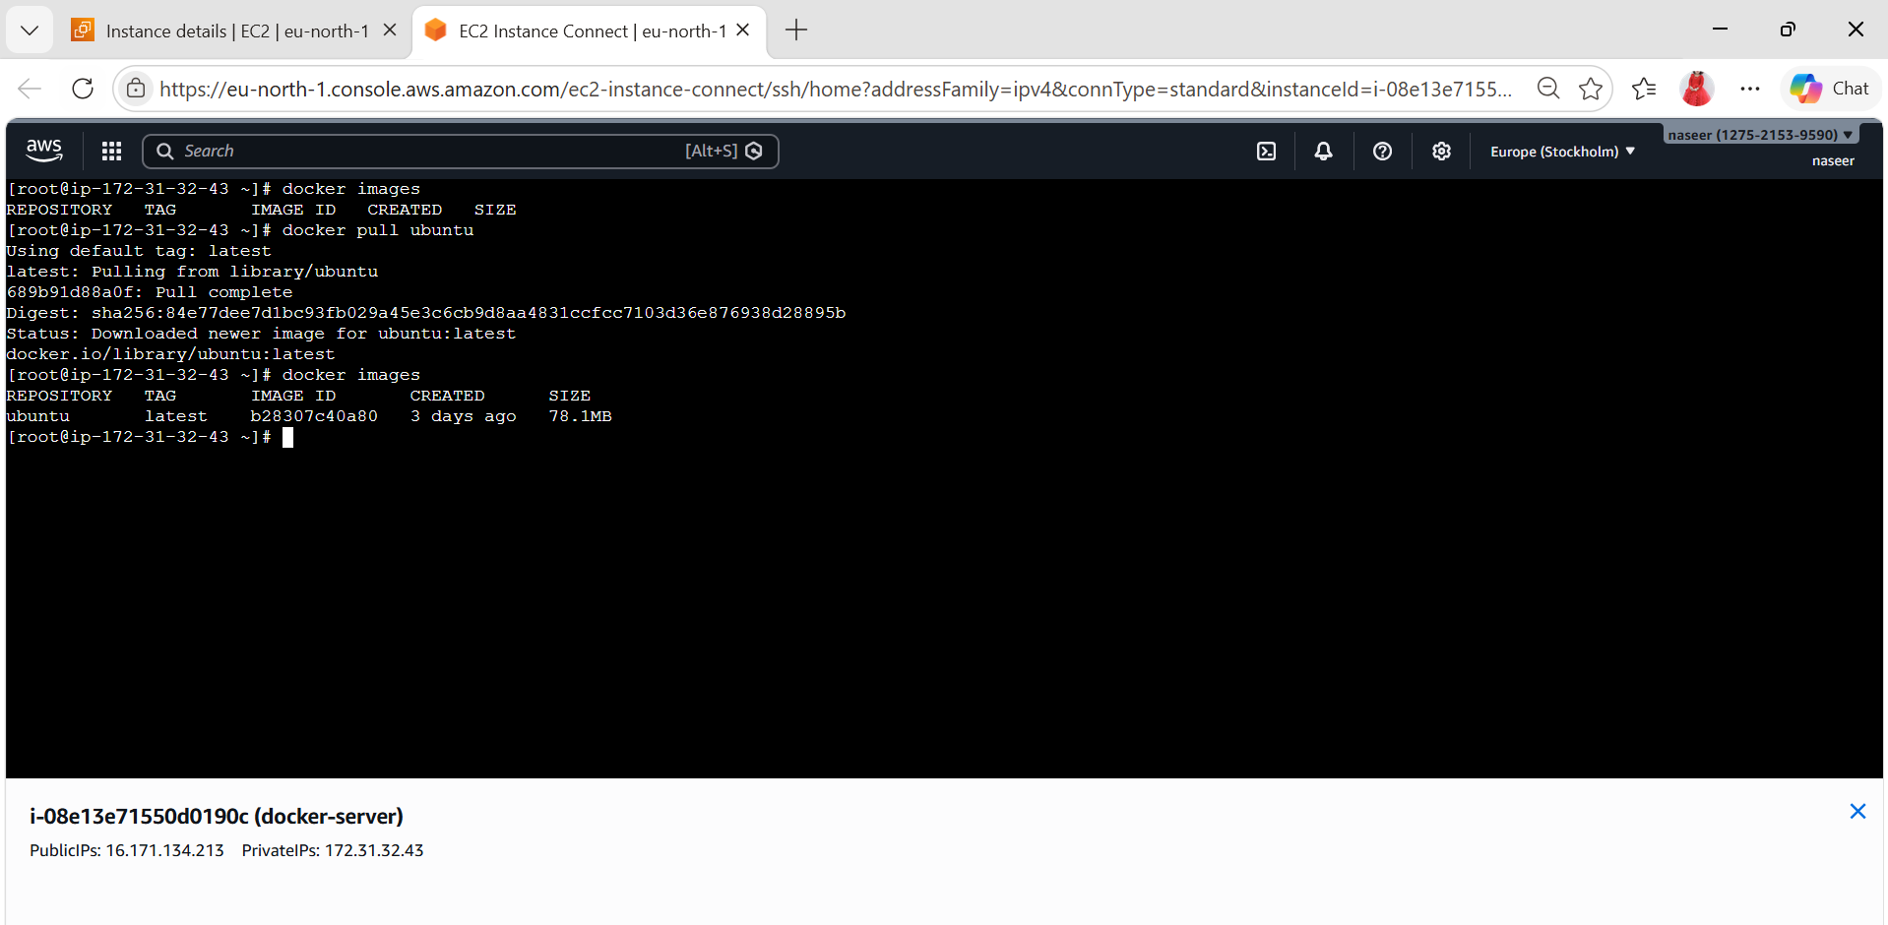
Docker image for Jenkins
docker pull Jenkins
docker images

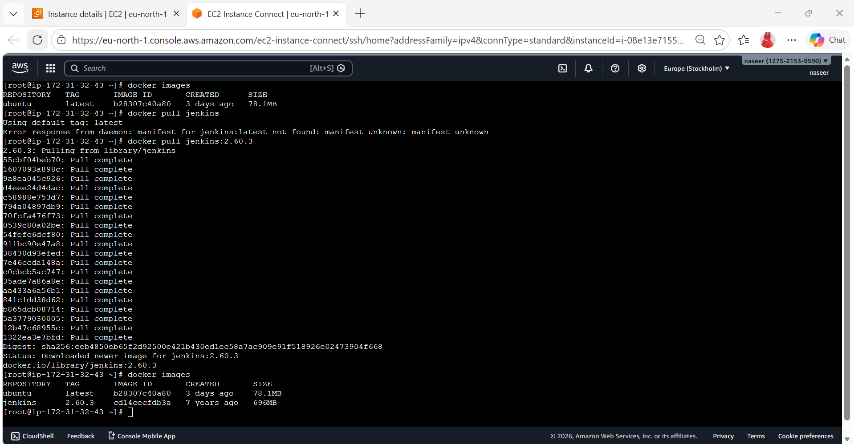

Docker image for SonarQube
docker pull sonarqube
docker images

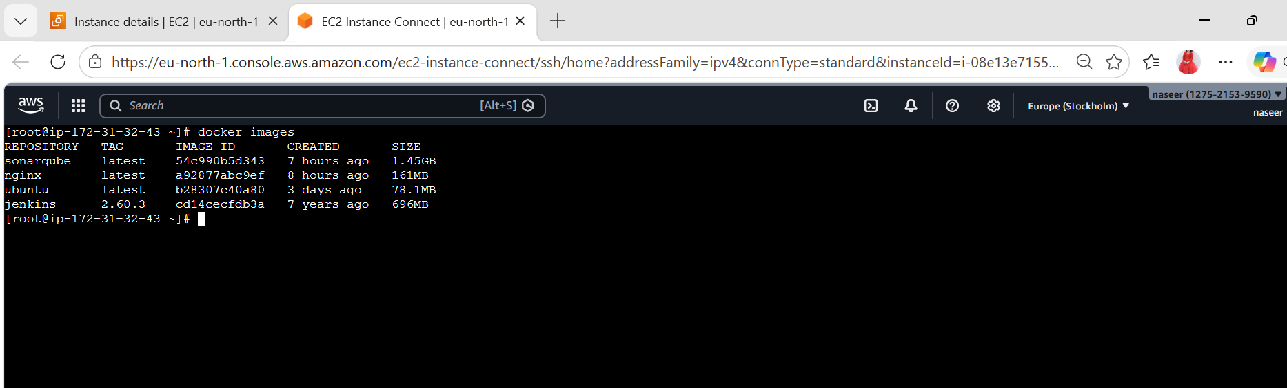

4) Run nginx container and expose on port 81.
docker images
docker container run -itd -p 81:80
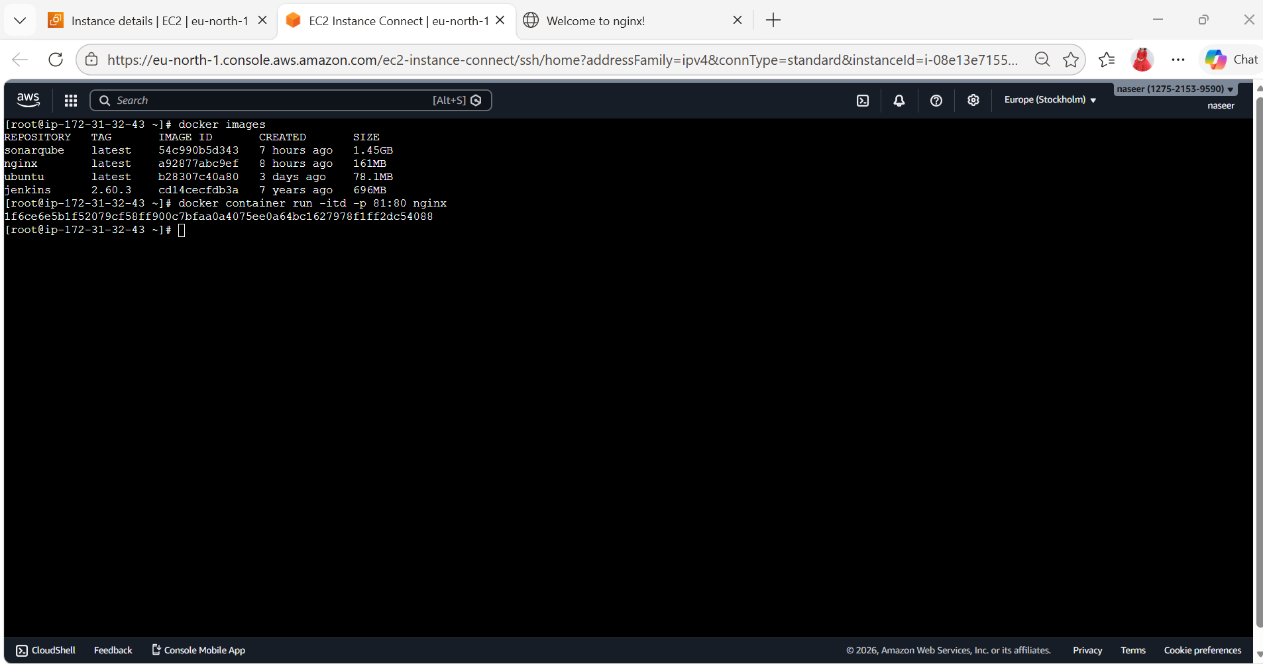
Browse:16.171.134.213:81
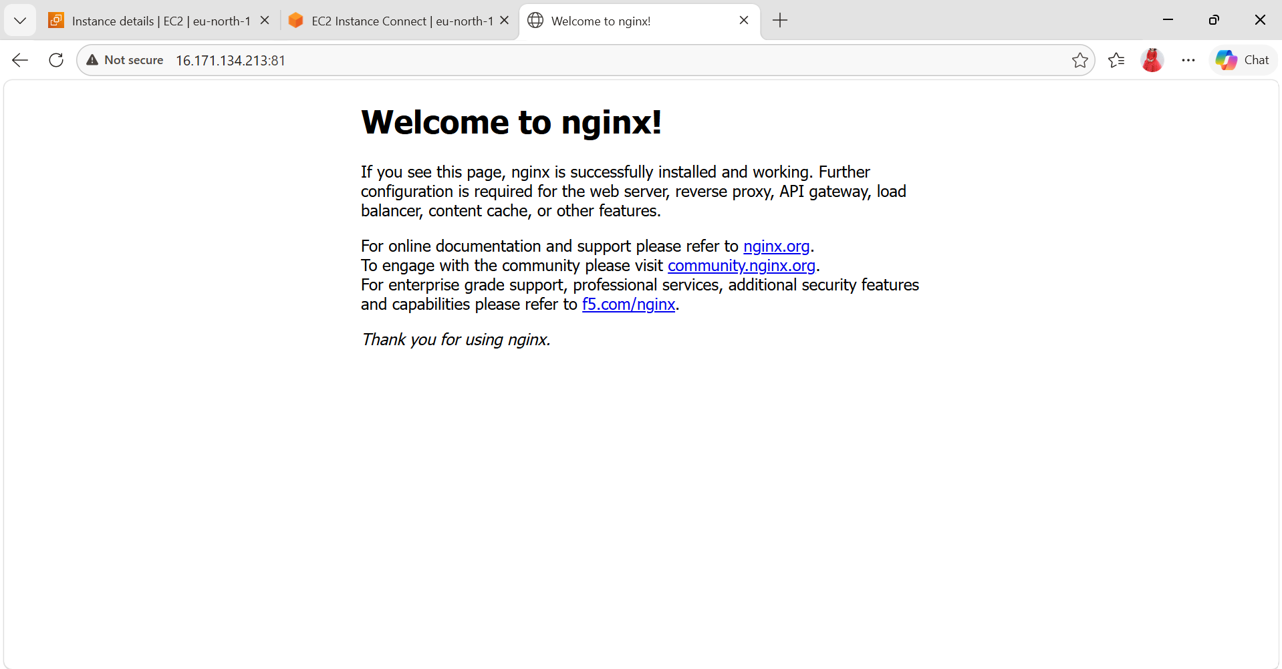

5) Delete the apache tomcat image from local.
docker images
docker image rmi imageid(tomcat) / docker rmi -f tomcat
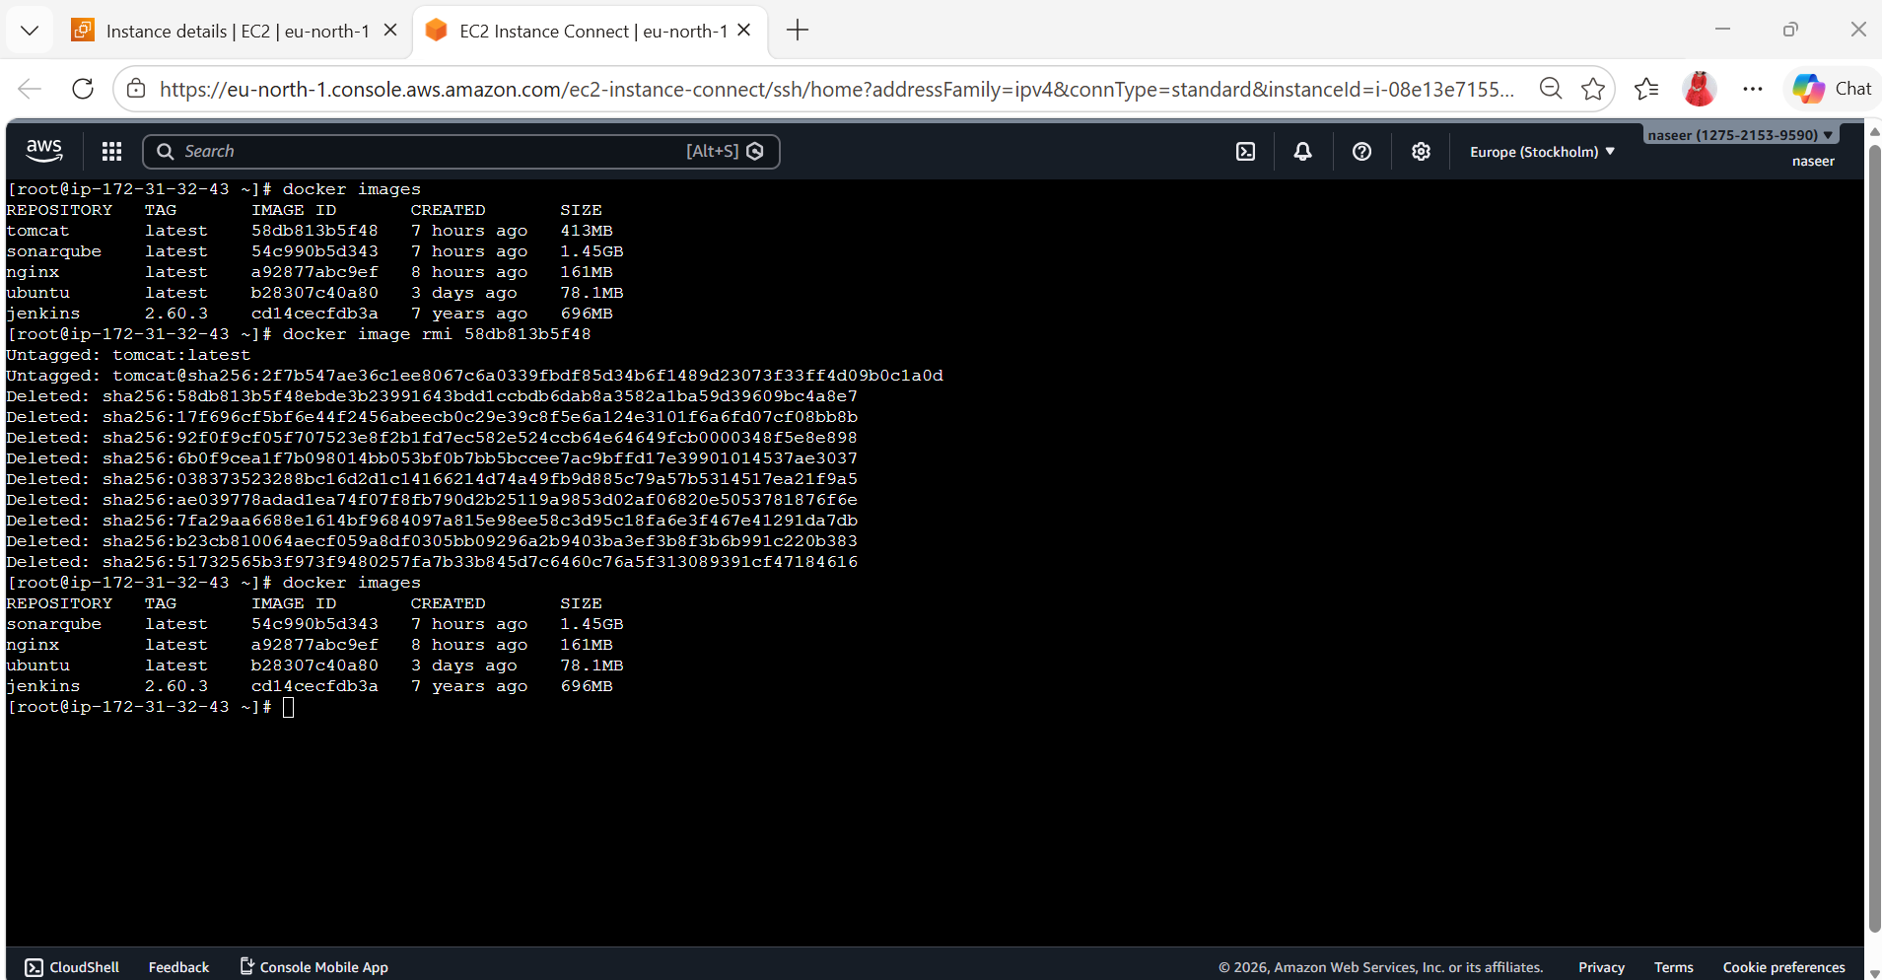
6) Inspect the jenkins image,sonarqube image.
docker images
docker image inspect Jenkins imageid
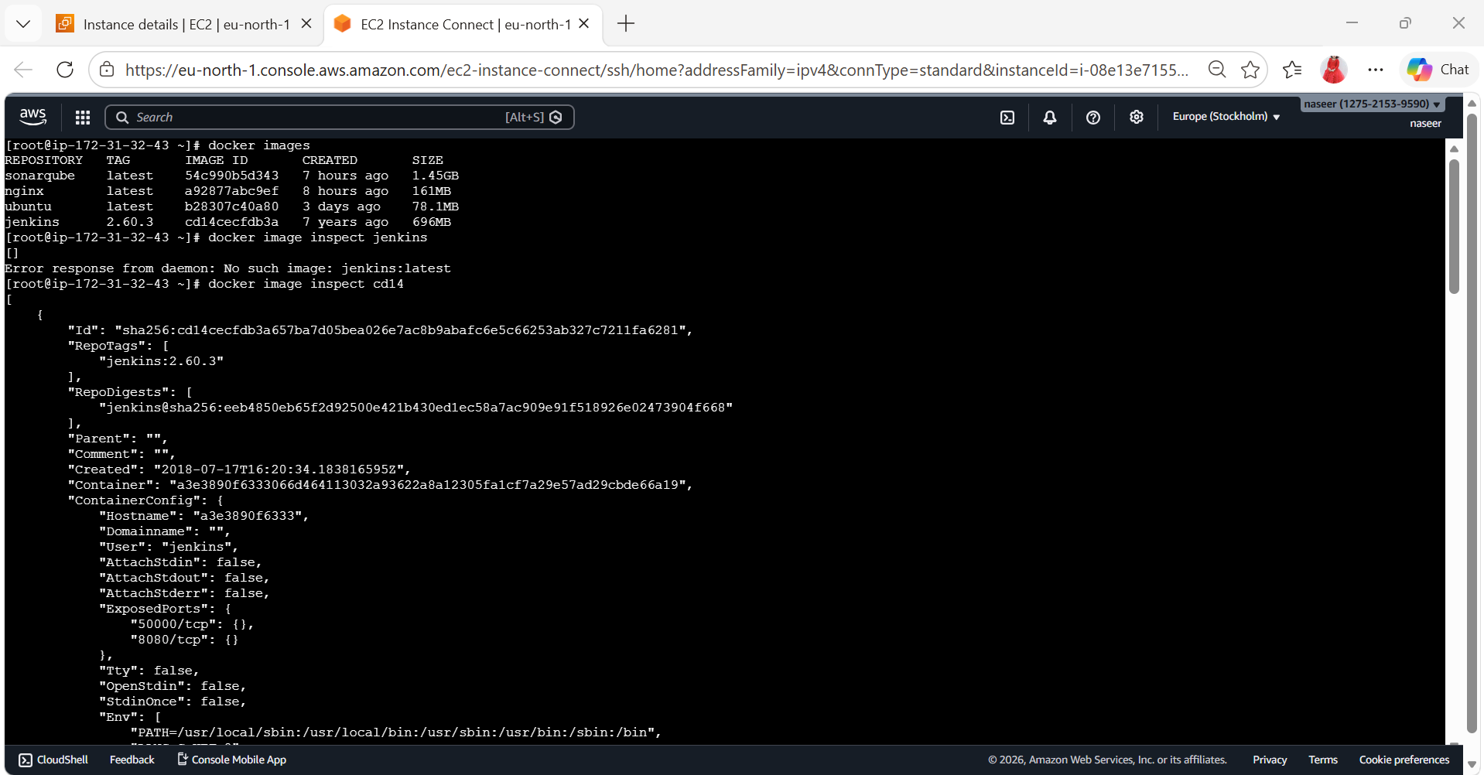
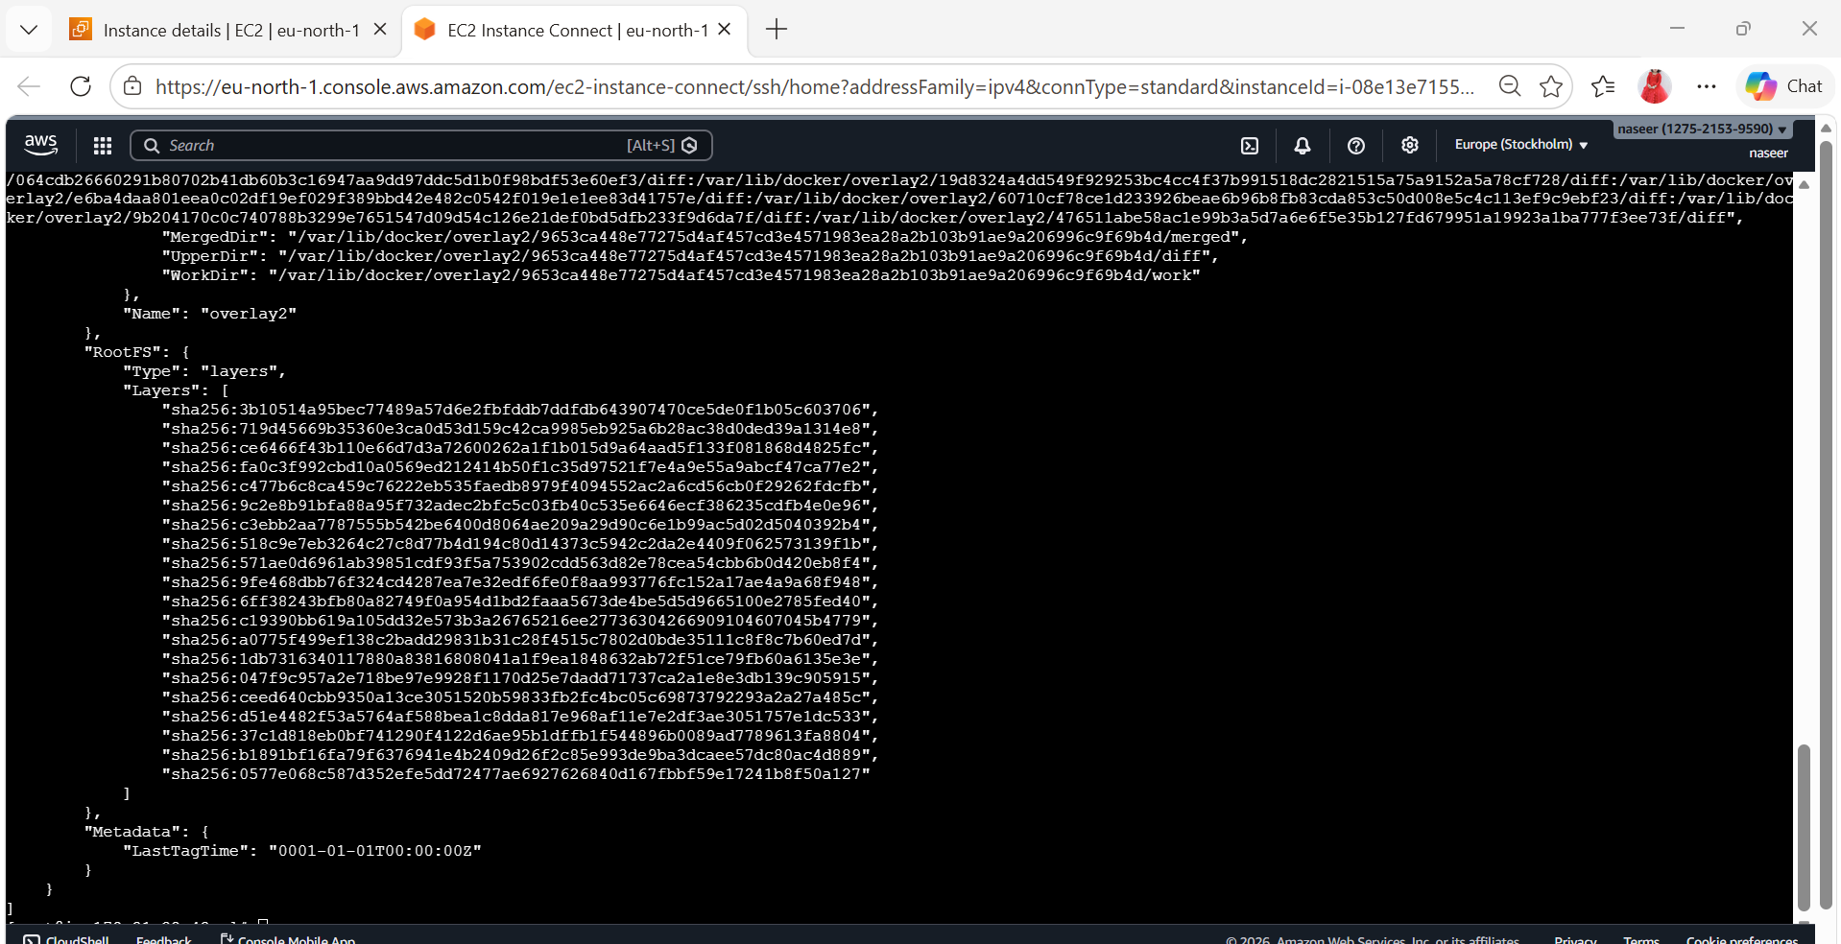

docker images
docker image inspect sonarqube

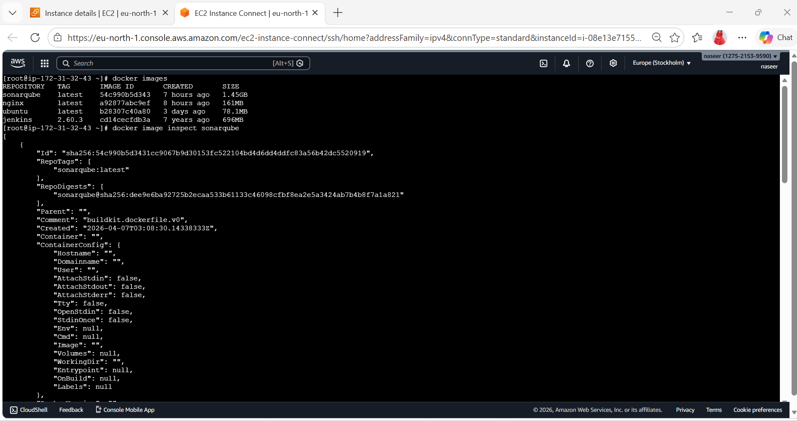
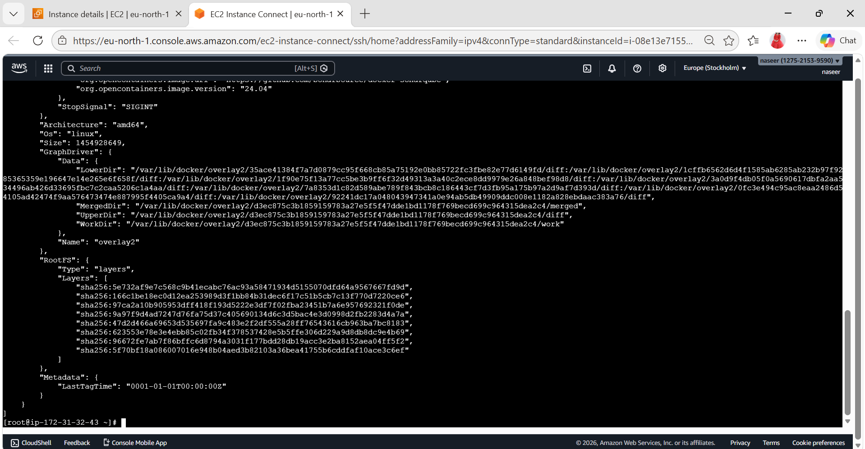
7) Run jenkins contianer and run one sample job. 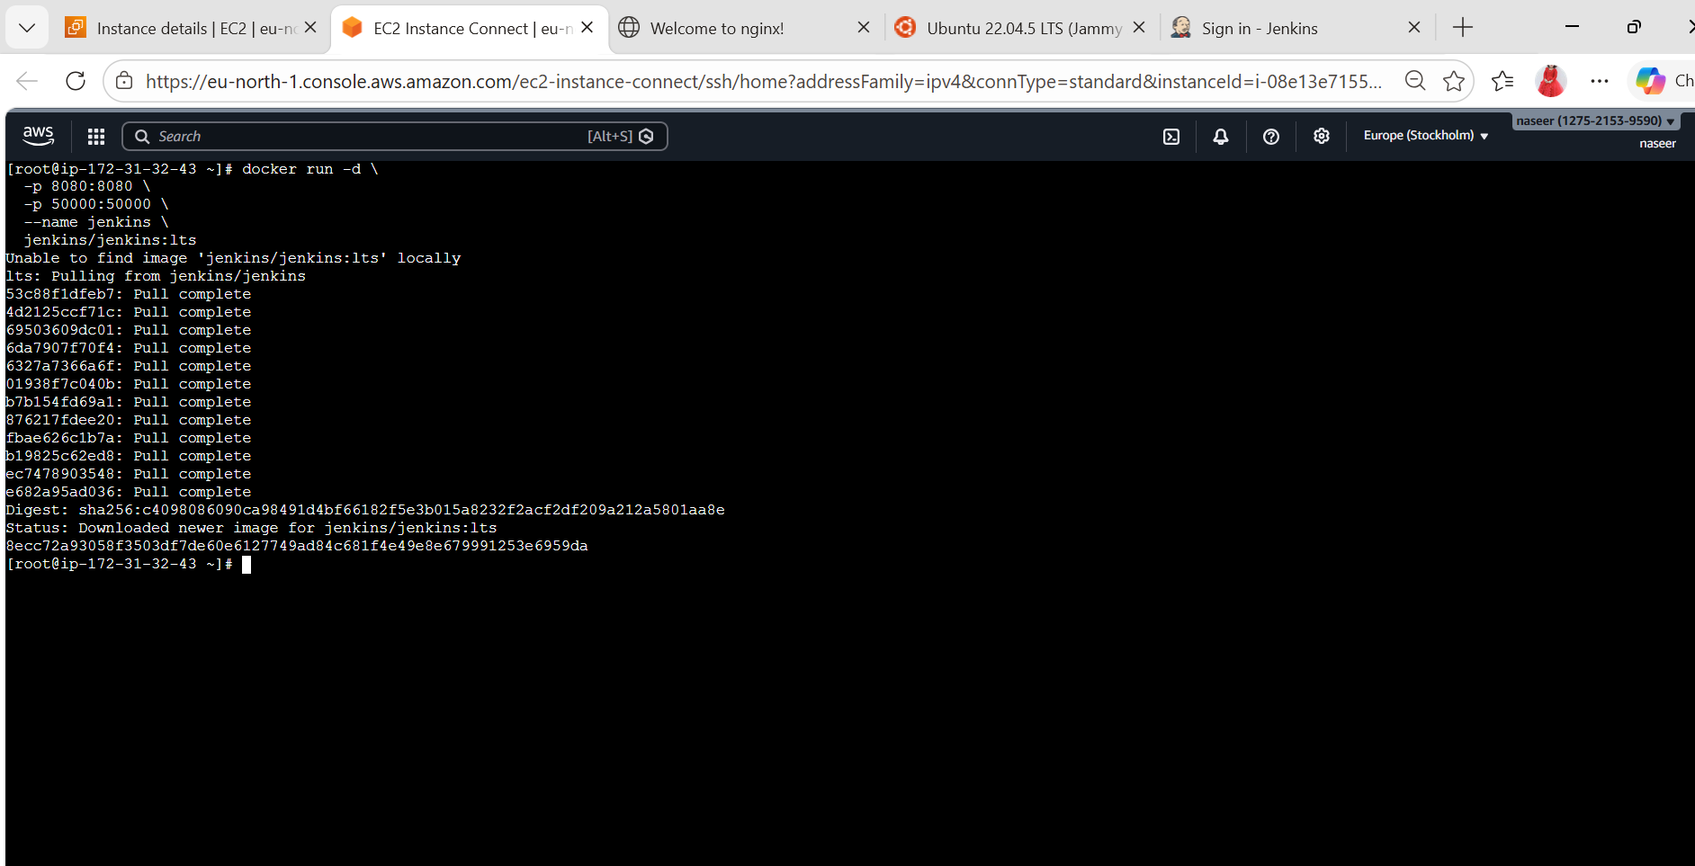
Unlock Jenkins
Get password:
docker exec jenkins cat /var/jenkins_home/secrets/initialAdminPassword
Open:
http://16.171.121:8080
Paste password → Install suggested plugins
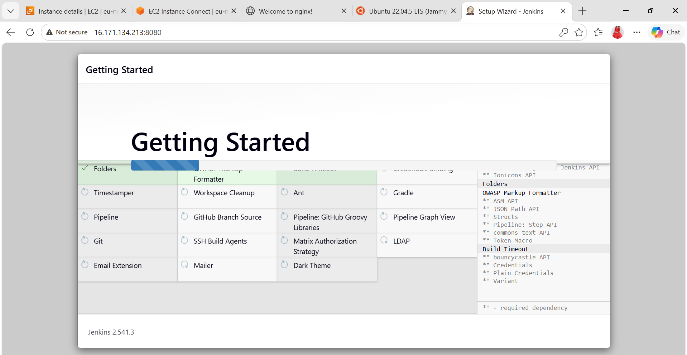
Create New Job
1. Click New Item
2. Enter name: sample job for docker
3. Select freestyle
4. Click OK
echo "Hello DevOps from Naseroddin Baba"

